# **Criteria for Analysis**

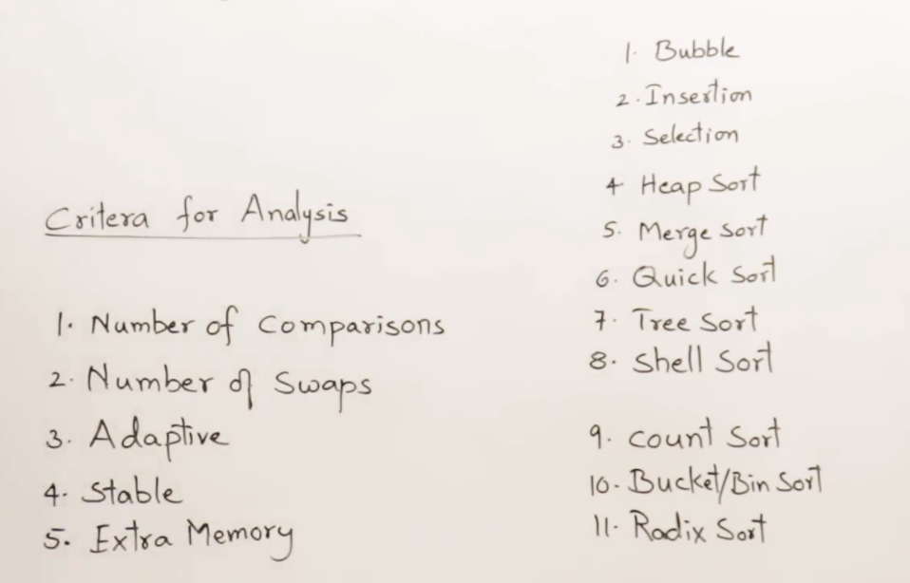

## **Number of comparisons**

## **Number of swaps**

Sorting algorithms are

Adaptive 🡪 If the elements are already sorted, then the sorting method must take some less amount of time.

## **Stable**

6 is the duplicate element.

Both are 6 but there exists for C’s and E’s

Initially first C’s 6 should come next E’s 6 should come. 🡪 this is the requirement

If there are duplicates, then the order must be preserved.

If a sorting algorithm is preserving the order of duplicate elements in the sorted list,   
then that algorithm is stable.

Why we need to preserve the order???

Initially sort them based upon Name,   
So Name’s order is maintained and marks order is not maintained.

Then sort them based upon Marks  
So Marks order is maintained and name’s order is not maintained.

## **Extra Memory**

# **Over-view of all the algorithm**

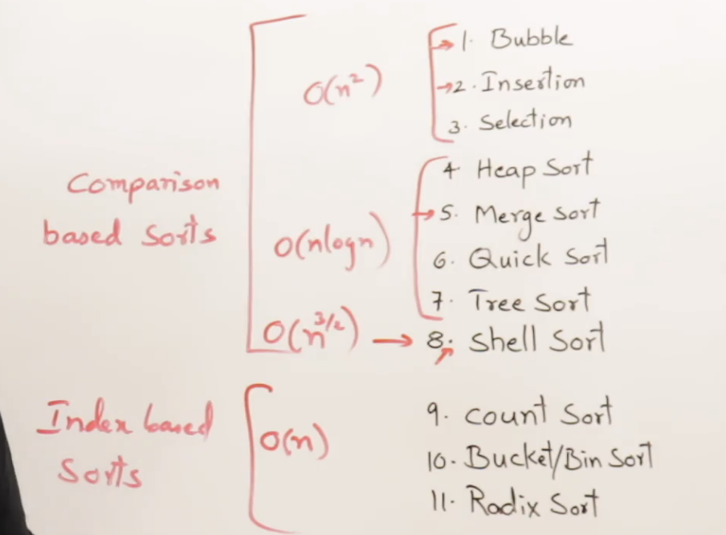

Not a sorted list

Time taken by any sorting algorithm 🡪 Depends upon number of swaps. -> Max Time

A Sorted list

Time taken by any sorting algorithm 🡪 Depends upon number of comparisons. -> Min Time